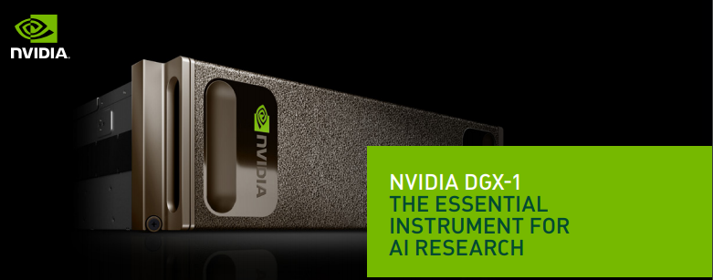
Dear Colleagues,

As you may know, the AI and Robotics lab, has recently bought a DGX1 (Deep Learning Server for AI Research | NVIDIA).
The DGX1 is the world's first purpose-built system for deep learning with fully integrated hardware and software that can be deployed quickly and easily. Its revolutionary performance significantly accelerates training time, making the NVIDIA DGX-1 the world's first deep learning supercomputer in a box (see details in the attachment).
To get access to the computational power of this machine we have built a friendly request system so that every faculty member can utilize the deep leaning server.

To request the GPU for a period of time you can simply:
- Register on the dgx1-request.aa.uaeu.ac.ae (accessible only from the internal UAEU network)
Note: If you are using a VPN, you will need to add the login server's IP to the hosts file on your computer to be able to resolve its IP properly. The line in the hosts file should look like:
10.90.216.26 dgx1-request.aa.uaeu.ac.ae
- Sign in and send a request with your requirements for a period of time.
- Wait before your request is approved to get an email with instructions how to get access to the resources.
- Copy your data and a model to your folder on the server.
- Access to the container and run your models from the terminal or Jupyter notebook.

Additionally, we want to draw your attention to a few points that you may find helpful:
1. Currently we provide access to 8X NVIDIA® Tesla® V100 GPUs with 32GB memory each. For the regular 2D-image processing deep learning task one GPU is enough. However, you can request more than one and parallel the training process. The maximum time frame for one task (request) is one week.
2. On the request page, after the number of GPUs and hours are chosen, our system will suggest you the best time slot available for your request. You are free to choose time manually or use our suggestion as it is.
3. You will be provided with access to the docker container running on the server. All containers as well as DGX1 work on Ubuntu OS. Therefore, if you need to install any auxiliary libraries, use Ubuntu commands.
4. Here is a link with containers and models, that are currently provided by NVIDIA for your kind reference https://ngc.nvidia.com/. If there is no container on our DGX1 server that you want to use, you can drop us an email with your specific requirements.
5. You can keep track on all your requests by visiting Account menu (dgx1-request.aa.uaeu.ac.ae/account). You can also cancel any of your requests on this page.
6. A section of FAQ is created for your kind reference, please consult with it first and if you have any further queries, don't hesitate to contact us.
7. Don't forget to change a default password (123456) to your server account to keep your sensitive data safe (To change a password run command passwd on your first login).

Acknowledgment
We would highly appreciate it if you could help us to justify the purchase of DGX1, by acknowledging AI and Robotics Lab of United Arab Emirates University for offering facilities such as a supercomputer DGX1 on the publication that you used the results that came out of DGX1. It will help us to buy more computational facilities in the future.

Thank you for your cooperation and support.
We are looking forward to facilitating your deep learning queries.
Best regards,
AI and Robotics Lab, UAEU

